**Bachelor’s in Special Education**

Department of Early Childhood, Special Education, & Counselor Education

University of Kentucky

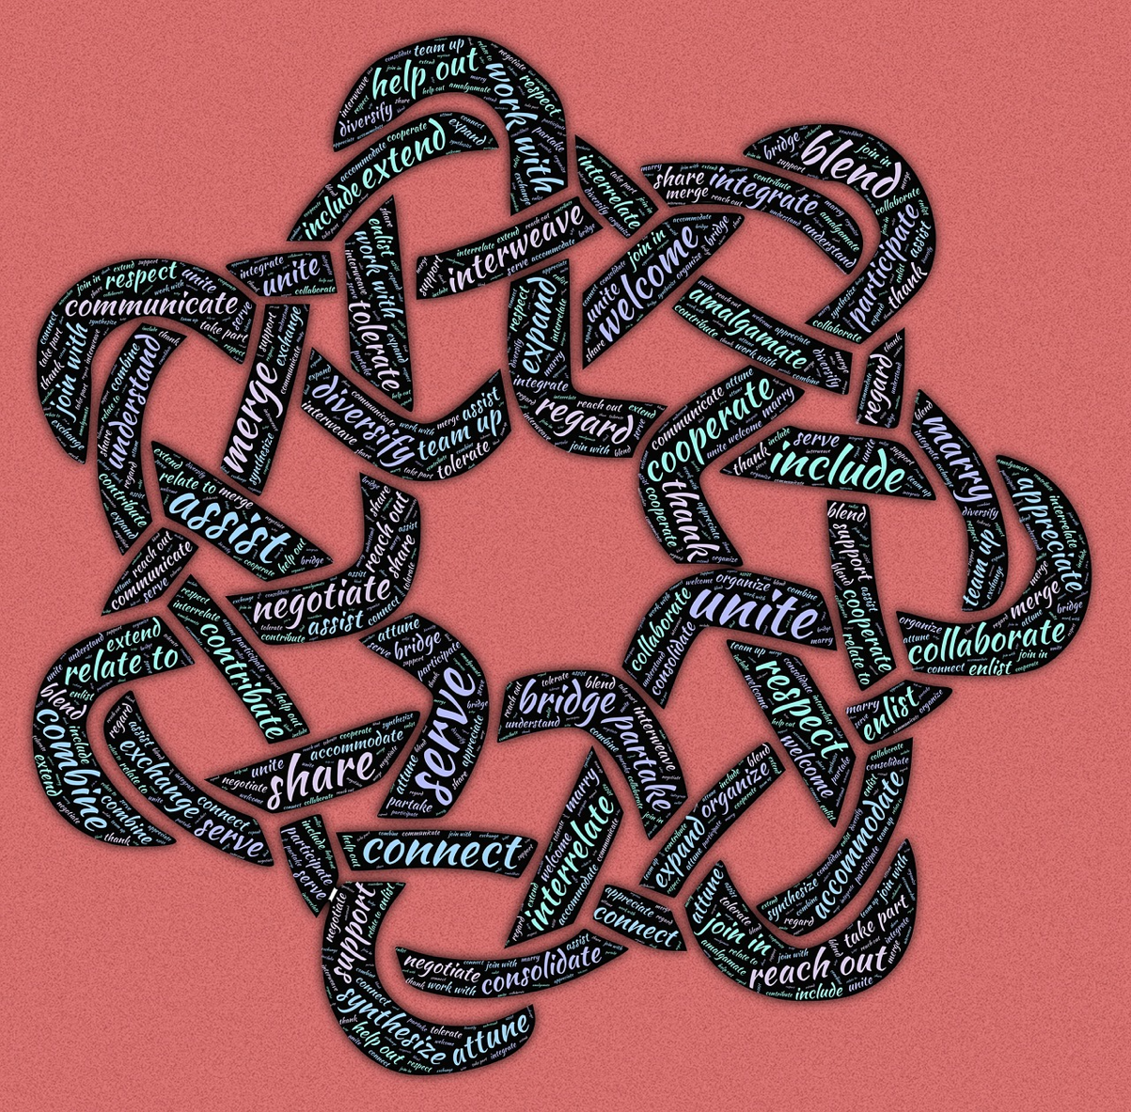

**Candidate Policies and Procedures Manual**

**2024**

**TABLE OF CONTENTS**

|  |  |
| --- | --- |
|  | Page |
| Welcome and Introductions………………………………………………………………………………………… | 3 |
| Introduction to the Faculty………………………………………………………………………………. | 3 |
| First Things First……………………………………………………………………………………………………..…… | 3 |
| Student Candidate Responsibilities…………………………………………………………..…….. | 3 |
| Electronic Housekeeping……………………………………………………………………………..….. | 3 |
| Classrooms, Libraries, Parking…………………………………………………………………..…….. | 3 |
| Dispositions, Expectations, Ethics………………………………………………………………………..….…… | 4 |
| KY Teacher Performance Standards…………………………………………………………..……. | 4 |
| Professional Commitments and Dispositions…………………………………………………… | 5 |
| Social Media Etiquette…………………………………………………………………………………….. | 6 |
| Dress Code Expectations……………………………………………………………………..…..……… | 6 |
| Faculty Expectations………………………………………………………………………………………… | 7 |
| EPSB Code of Ethics………………………………………………………………………………….……… | 7 |
| Course Sequence …………………………….……………………………………………………..……………….…… | 8 |
| Coursework……………………………………………………………………………………………………… | 8 |
| Retention and Dismissal………………………………………………………………………………………….……. | 9 |
| Ombud Services…………………………………………………………………………………..…………… | 9 |
| Tuition Information………………………………………………………………………………………………….…… | 9 |
| Teacher Certification Application Process ……………………….…………………………………………… | 10 |
| Licensure Disclosure………………………………..……………………….…………………………………………… | 10 |
| Resources………………………………………………..……………………….…………………………………………… | 10 |
| Final Thoughts……….………………………………..……………………….…………………………………………… | 10 |
| Appendix……………….………………………………..……………………….…………………………………………… | 11 |
|  |  |
|  |  |

### Welcome and Introductions

Welcome to the Special Education Program at the University of Kentucky! Our program has the reputation of preparing many of the best teachers in Kentucky and is part of the #1 ranked Education School in the state in 2023 by U.S. News and World Report. Our mission is to prepare teacher candidates to educate students who qualify for special education services in Kentucky and around the United States. Upon completion of our program, candidates are eligible for two P-12 certifications in the state of Kentucky: Learning and Behavior Disorders and Moderate and Severe Disabilities.

**Introduction of the** **Special Education Faculty**

Our team of professors are experts in the fields of assessment; applied behavior analysis; behavior management; systematic instruction; and methods for teaching academics, social/communication, and adaptive behavior skills. When you graduate from the Special Education Program at UK, you can be assured that you will be a highly trained professional ready to serve your population of learners. The faculty, including their areas of expertise, can be found on our [website](https://education.uky.edu/edsce/people).

**First Things First**

The B.S. in Education program in Special Education requires completion of (1) the UK Core requirements, (2) specified course work in Related Studies and Professional Education, and (3) specified course work in the special education.

**Student Candidate Responsibilities**

Candidates also should review the [Student Rights and University Policies](https://regs.uky.edu/sites/default/files/2023-07/AR4-10StudentCode-FINAL-ApprovedbyBOT6-6-23edits7.26toREPOST.pdf) information found on the website. This document contains information regarding expected standards of student behavior and performance.

**Electronic Housekeeping**

Taking care of some electronic housekeeping at the beginning of the semester will save you time - and possibly grief - in the months to come. We try and give some helpful hints and guidance in the sections that follow.

**Classrooms, Libraries, and Parking**

What follows is a brief introduction to your surroundings at the University of Kentucky campus. We have included some helpful links to detailed campus maps for your convenience.

**Classrooms**

Most classes will be held on campus at either Dickey Hall (DH) or Taylor Education Building (TEB). The physical address for TEB is 597 S. Upper Street, Lexington, KY. Although TEB is on Upper Street and DH is on Scott Street, the buildings are connected by a breezeway and the parking options should be identical. To locate directions to any building on campus visit the link: <http://www.uky.edu/CampusGuide/>.

**Libraries**

The University has a host of libraries across campus. The one most relevant to you is the [Education Library](https://libraries.uky.edu/locations/education-library) that is located on the second floor of Dickey Hall in 227 Dickey Hall. The education librarian is Lisa Nichols (lisa.nichols[@uky.edu](mailto:jeretta.robinson@uky.edu)), who also can assist you with accessing materials using the electronic databases. The distance librarian for distance candidates is Carla Cantagallo, Distance Learning Services ([carla@uky.edu](mailto:carla@uky.edu), 859-218-1240).

**Parking**

The map below shows nearby parking to TEB and DH. Parking is available behind TEB and in a Scott Street lot (marked in red on map), however you will need to obtain an evening parking permit from [Transportation Services](https://www.uky.edu/transportation/) to park there. There is also city parking along Scott Street and Upper Street in which you pay a parking meter (marked in green on map). Finally, the Cornerstone Garage is close to TEB (marked in blue on map), where you can park as a guest for a fee.

**Dispositions, Expectations, Ethics**

The University of Kentucky Special Education Teacher Education Program (SPED TEP) adheres to the standards set forth by the Education Professional Standards Board (EPSB) of Kentucky regarding teacher education. What follows are the standards, dispositions, and expectations set forth by EPSB and the University of Kentucky Teacher Education Program unit. All candidates in the SPED TEP are expected to demonstrate the standards, dispositions, and expectations summarized herein throughout their participation in the teacher education program.

**KENTUCKY TEACHER CODE OF ETHICS**

1. Shall exemplify behaviors which maintain the dignity and integrity of the profession;
2. Shall accord just and equitable treatment to all members of the profession in the exercise of their professional rights and responsibilities;
3. Shall keep in confidence information acquired about colleagues in the course of employment, unless disclosure serves professional purposes or is required by law;
4. Shall not use coercive means or give special treatment in order to influence professional decisions;
5. Shall apply for, accept, offer, or assign a position or responsibility only on the basis of professional preparation and legal qualifications; and
6. Shall not knowingly falsify or misrepresent records of facts relating to the educator's own qualifications or those of other professionals.

**University of Kentucky Professional Commitments and Dispositions**

The combined program faculties of the UK educator preparation unit have established five Functional Skills and Dispositions that underlie all UK Teacher Education Programs. The required functional skills and dispositions can be thought of as your rules while you are in our program, and are as follows:

**Functional Skill and Disposition 1:** Candidates communicate appropriately and effectively.

* Communicates orally in formal presentations.
* Communicates with individuals in small groups in informal settings.
* Uses nonverbal communication skills.
* Communicates in writing (reports, essays, letters, memos, e-mails)

**Functional Skill and Disposition 2:** Candidates demonstrate constructive attitudes.

* Demonstrates knowledge and command of socio-cultural variables in education.
* Demonstrates constructive attitudes toward children, youth, parents, and the community.
* Demonstrates awareness and acceptance of diversity in educational settings.

**Functional Skill and Disposition 3:** Candidates demonstrate ability to conceptualize key subject matter ideas and relationships.

* Correctly states key subject matter ideas.
* Explains key subject matter ideas.
* Tailors key subject matter ideas to diverse populations
* Addresses misconceptions in key subject matter ideas.
* Identifies real life examples to enhance student learning.

**Functional Skill and Disposition 4:** Candidates interact appropriately and effectively with diverse groups of colleagues, administrators, students, and parents in educational settings.

* Demonstrates acceptable educator behavior in diverse educational settings.
* Demonstrates adaptability in reflecting on self in relation to diverse groups.
* Plans, teaches, and assesses in a culturally responsive manner.

**Functional Skill and Disposition 5:** Candidates demonstrate a commitment to professional ethics and behavior.

* Demonstrates understanding of the Kentucky School Personnel Code of Ethics
* Complies with all legal requirements required of educators in a knowledgeable and timely manner.
* Demonstrates understanding of ethical issues related to the special education certification area.

**Social Media Etiquette Recommendations**

Students must demonstrate professional and ethical conduct in all relationships when using social media. It is the student's’ responsibility to understand how social media can positively or negatively impact various employment opportunities. The following outlines pros, cons, and cautions when using social media outlets.

**PROS:**

* Encourages communication and interaction.
* Allows easy networking and sharing of professional resources.
* If used correctly, personal sites show online responsibility with digital resources.

**CONS:**

* Easy access to dangerous and risky sites and images
* Allows the quick spread of unreliable or slanderous information.

**CAUTIONS:**

* Your personal site is a reflection of you, the university, and the school in which you are placed.
* You must be extremely cautious ***at all times*** with what you post on any of your personal, private, or even professional accounts.
* Consider the message you are portraying.
* Avoid obscenities, rude gestures, and any conduct that can be perceived as unprofessional or disrespectful.
* Avoid posting pictures or information that link you with illegal activity.
* Avoid posting slanderous or malicious content about anyone.
* Avoid texting about school-related personnel, students, or events.
* ***NEVER*** reveal information about the school settings in which you are placed.
* ***NEVER*** post photos or videos of students
* Always put your best face forward

**Dress Code Expectations**

All candidates should have a neat, clean appearance that does not distract from the educational activities and depicts a professional individual prepared for the activities of the day. Please check the dress code of the district(s) in which you will be placed and follow those guidelines. General guidelines are below:

* Be mindful of your hygiene by brushing your teeth, bathing, having clean and groomed hair, and applying deodorant daily. Shave or groom and maintain facial hair to ensure a neat and hygienic appearance.
* Shorts and ball caps are not permitted; sneakers are only permitted as appropriate.

Additionally, the following are prohibited:

* Wearing items or tattoos that reference activity that is either illegal outright or prohibited for minors (e.g., clothing that promotes the use of drugs, alcohol, or tobacco or other criminal activity).
* Wearing items that display messages of bias, including any type of attire or tattoos that contains language which advocates or demonstrates approval of discrimination based on ethnic background, color, race, national origin, religious belief, sexual orientation, or disability.
* Wearing items that are overly revealing, suggestive, obscene, or lewd, including any type of attire that is likely to expose parts of the body with movement, those that expose body contours or regions of the body (e.g., tube tops, cut off shirts, sagging pants, “bare midriff” tops), and those that are tailored from transparent materials or improperly maintained.

**Faculty Expectations**

You have just read a lot about our expectations of YOU as a student candidate. There are things you can expect from the faculty in our program. These things include, but are not limited to:

* Coming to class prepared
* Providing course content in organized and informative class sessions
* Presenting you with the most current information and research from the field of special education
* Responding to you promptly (as indicated on the front page of your syllabus)
* Evaluating performance and products fairly
* Creating an environment in which ideas may be shared openly

**Professionalism:EPSB Professional Code of Ethics for Kentucky Certified School Personnel**

KRS 161.028 requires that the Education Professional Standards Board develop a professional code of ethics. This administrative regulation establishes the code of ethics for Kentucky school certified personnel and establishes that violation of the code of ethics may be grounds for revocation or suspension of Kentucky certification for professional school personnel by the Education Professional Standards Board. The code of ethics set forth by the Education Professional Standards Board follow. Follow this link to the full Code of Ethics: <http://www.epsb.ky.gov/mod/page/view.php?id=55%22>

**Course Sequence**

The B.S. in Special Education degree course sequence is prescribed and must be taken in the block outlined. Additionally, the courses must occur concurrently with the clinical experiences outlined. Deviation from the course sequence is not permitted as many courses are only offered once per academic year.

|  |  |  |  |
| --- | --- | --- | --- |
| Semester | Course | Hours (Total Hours) | Purpose/Information |
| Sophomore  Fall | EDS 375 (3)  PHY 160 or EES 160 (3)  Elective (3)  Elective (3)  EDS 513 (3) | 15 (46) | Related Studies  Students will have 2 electives to take this semester. These could include PSY 100, STAT 210, MA 211, EPE  301 if not taken in CORE |
| Sophomore Spring | MA 201* (3)  EDS 301 (1)  EDS 570 (3)  EDS 505 (3)  EDS 526 (3)  EDS 547 (3) or EDS 516 (3) | 15 (61) | Can apply for SPED TEP Admission. Must have completed EDS 375 and at least enrolled in current courses to apply for TEP admission. EDS 301 is 4 hours per week (30 hours) in LBD setting |
| Junior Fall | EDS 516 (3) or EDS 547  EDS 517 (3)  EDS 530 (3)  EDS 500 (3)  EDS 301 (1) | 15 (75) | Can re-apply for TEP Admission. Initial Practicum – 4 hours per week (30 hours) – in MSD setting. |
| Junior Spring | EDS 548 (3)  EDS 549 (3)  EDS 518 (3)  EDS 401(3)  EDC 326 (3)  SEM 328 (3) | 18 (93) | TEP ONLY  Intermediate Practicum – 7 hours per week (90 hours) – MSD placement |
| Senior Fall | EDS 529 (3)  EDS 528 (3)  EDS 402 (3)  SEM 337 (3)  EDC 339 (3) | 15 (108) | TEP ONLY  Advanced Practicum – 7 hours per week (90 hours) – LBD placement |
| Senior Spring | EDS 550 (12) | 12 (120) | TEP ONLY  *EDS 550 will be 8 weeks MSD and 8 weeks LBD |

* Candidates ***MUST*** pass MA 201 with a “B” or better.
* Candidates ***MUST*** earn a grade of “C” or better in all EDS courses, an earned grade below “C” will result in the development of a Support Plan to ensure remediation of concerns and to outline how adequate progress will be demonstrated moving forward. A copy of the Support Plan will be submitted to the Academic Advisory and an Academic Alert will be initiated.

**Retention Review and Dismissal**

Candidates admitted to the Special Education Teacher Education Program will be continuously assessed based on performance in all coursework, dispositions, and field placements. Candidates must maintain a 2.75 grade point average and consistently demonstrate functional skills and dispositions and ethical behavior as evaluated each semester throughout the program in accordance with the College of Education’s Functional Skills and Dispositions.

If a candidate needs to be warned, placed on probation, suspended, or excluded from the program, they will be notified in writing and placed on a Support Plan. The Support Plan will contain candidate strengths, growth areas, and a progress monitoring timeline. If adequate progress is not consistently demonstrated the program faculty will meet to determine if dismissal from the program is advisable. Appendix A contains the Candidate Retention Review Form.

**Ombud Services**

The Office of Academic Ombud Services is responsible for assisting students and instructors in working through and resolving academic related problems and conflicts. The major arenas of activity for UK’s Academic Ombud include both Student Academic Rights and Academic Offenses. The primary focus of Academic Ombud Services is the process by which decisions are made, and the primary task of the Ombud is to ensure fair policies, processes, and procedures that are equitably implemented. Thus, the Academic Ombud is a neutral party working as an advocate for fairness and equity.

* Services provided by the ombudsman include but are not limited to:
  + Grade disputes
  + Admission/registration problems
  + Disciplinary matters
  + Perceived favoritism
  + Fear of retaliation
  + Charges of and sanctions resulting from plagiarism or other academic offenses
  + Disability accommodation issues
  + Cross-cultural misunderstandings & personality conflicts

*Contact Information:* 109 Bradley Hall (859)257-3737

[ombud@uky.edu](mailto:ombud@uky.edu) <http://www.uky.edu/Ombud/>

### Tuition Information

You can find tuition refund policies, deadlines, amounts and other important information on the [UK Student Account Services](https://www.uky.edu/studentaccount/student-account) website and the [Registrar’s Tuition and Fees](https://www.uky.edu/financialaid/tuition-and-fees) website.

### Teacher Certification Application Process

Once you have completed your degree program at the University of Kentucky you will be eligible for two certifications in the state of Kentucky. To assist you in this process, we have prepared a [Power Point presentation which you can find here](https://docs.google.com/presentation/d/1Pp5gDPFuhHu98h0iOY0LOLH_ngqwhzd5/edit?usp=sharing&ouid=107401196870950872645&rtpof=true&sd=true). If you have additional questions, please contact Christopher Reese ([christopher.reese@uky.edu](mailto:christopher.reese@uky.edu), 859-257-4112).

### Licensure Disclosure

States may have additional requirements for programs that lead to professional licensure or certification. If you plan to use the degree to seek licensure, you should also determine if the degree meets the educational requirements for licensure in your state. Visit the [State Authorization and Licensure](https://www.uky.edu/academics/online-programs/faculty-resources/out-of-state-authorization) website to learn more about your program.

**Resources**

The University has a plethora of resources for students both inside and outside of the classroom. A link to resources for students can be found [here](https://students.ca.uky.edu/campusresources).

**Final Thoughts**

The special education program is delighted that you have chosen us for your undergraduate educational experience. We have a state-of-the-art faculty who are dedicated to your education and preparing individuals who serve those with disabilities well. If you ever need assistance beyond what you are receiving in your courses, do not hesitate to contact your professor, the Program Faculty Chair (Dr. Channon Horn, channon.horn@uky.edu), or the Department Chair (Dr. Melinda Ault, melinda.ault@uky.edu).

**Appendix A**

**DEPARTMENT OF EARLY CHILDHOOD, SPECIAL EDUCATION**

**AND COUNSELOR EDUCATION**

**CANDIDATE EXLUSION POLICIES**

The Department of Special Education is designed to prepare candidates to assume certified special educator teaching positions. In addition to maintaining a high level of competence in academic work, it is expected that candidates exhibit desired dispositions consistently. These include the following:

1. Commitment to the field of Special Education.

2. A work ethic that is characterized by consistent and sustained effort.

3. Ability to communicate effectively with other professionals.

4. Flexibility and responsiveness to educational change.

5. A high level of professional behavior.

The faculty in the department believe that candidates should exhibit high levels of professional and ethical behavior throughout the program. The faculty have a professional responsibility to do everything possible to ensure students are diligent in their pursuit of excellence. This includes the exclusion of candidates who are unwilling or unable to meet these expectations.

Candidates may be excluded from the program for the following reasons:

1. Violation of the student code that can result in termination from any program. The student code of conduct can be found at [this link](http://www.uky.edu/studentconduct/code-student-conduct).

2. Violation of the EPSB Professional Code of Ethics for Kentucky Certified School Personnel

3. Violation of the Council for Exceptional Children Code of Ethics. The code of ethics can be found at this [link](https://exceptionalchildren.org/sites/default/files/2020-07/Code%20of%20Ethics.pdf).

4. Failure to remove incomplete grades as specified on the incomplete contract.

5. Failure to maintain a minimum GPA of 2.75 for two consecutive semesters.

6. Failure to fulfill practicum expectations as outlined in the course syllabi and or indicated by the cooperating teacher.

7. Failure to obtain satisfactory ratings on the final evaluation from cooperating teacher(s) during student teaching experiences.

In implementing this policy, the following procedures will be employed. During the annual candidate evaluation, the Program Faculty Chair will solicit feedback from all faculty and cooperating teachers regarding all students currently enrolled in the Teacher Education Program. The Program Faculty Chair will then review all available information and provide written feedback that will be conveyed to each candidate.

If there are areas that need improvement, these will be noted in a Support Plan. The Support Plan will contain candidate strengths, growth areas, and a progress monitoring timeline.

In extreme cases (e.g., Student Code violation, ethical violation, or conviction of a crime), the Program Faculty Chair may recommend immediate exclusion from the program. In most cases, however, this would not occur until a student has been on probation and has been given an opportunity to rectify deficiencies.

### CANDIDATE RETENTION REVIEW

Academic Services and Teacher Certification: Education Preparation Program, University of Kentucky (ver1.3, Fall, 2012) 166 Taylor Education Building; Lexington, KY 40506-001; Phone (859) 257-7971

Candidate Name: Candidate LINKBLUE ID:

TEP Program Committee: *This committee has conducted a retention review for the candidate. The status has been set for the candidate:*

_____Candidate continue in good standing _______ Candidate Warned

_____ Candidate Placed on Probation. ________Candidate Suspended from Program

_____ Candidate Excluded from Program

*Note: Reasons for Warning, Probation, Suspension or Exclusions should be checked, and the time/date of the next retention review must be specified. A standalone memo to student can be included.*

**Reasons for Probation, Warning, Suspension or Exclusion Status:** (Check all that apply)

Problem with Functional Skills or Disposition

Problem with Technology Standards

Problems with KTPS

Problem with Program-related Standards

Problems with Subject coursework or subject standards

Problems with field experiences, practicum, or student teaching

Issues associated with the candidate Professional Growth Plan

Other- Specify:_______________________________________________

**Date/time for Next Retention Review if Candidate Status is NOT Continued in Good Standing:**

|  |  |
| --- | --- |
|  | **Memo to Student** (*This memo will appear on the letter sent to the student from TEB 166. The memo will be typed exactly as it is stated. If needed, an optional letter may be attached to the report to the student. Also, please attach a copy of the Professional Growth Plan as Reviewed and/or Amended, if appropriate)*  ***Program Faculty Chair Signature____________________________Date_______________________________*** |